**DAY 1- Problem Solving and Logic Building**

**Khushi Agrawal**

1. Step 1: Start.

Step 2 : Read a b c.

Step 3: s=a+b+c/2.

Step 4 : Area = ss-as-bs-c1/2

Step 5 : Print Area.

Step 6: Stop.

2.

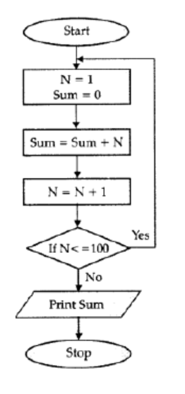

3. 1. Start

2. Enter (assigne) value of the variable (addend) X

3. Enter (assigne) value of the variable (addend) Y

4. Calculate Z (Z = X + Y)

5. Display result of addition, value of Z on the monitor with the message "The sum of X and Y is:"

6. Ask the question "Do you want to re-start the program <Y / N>?" and set value to the response variable ANSWER

7. If the ANSWER is "Yes," go to Step 1

8. If the ANSWER is "No," go to Step 9

9. End

4.

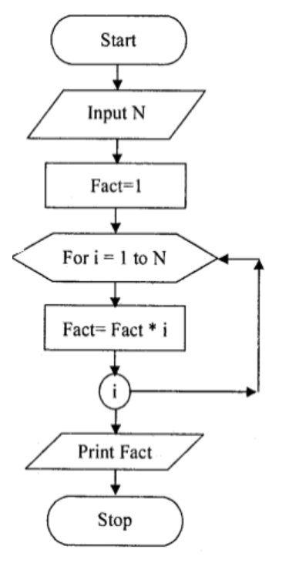

5. **Step 1 :** START

**Step 2 :** Declare variables  p , n , r  and  si .

**Step 3 :** Read the values of variable  p ( principal ) , n ( Number of years ) , r ( Rate of Interest ) .

**Step 4 :** calculate the values of  “ si = ( p * n * r )/100 “ .

**Step 5 :** Display si ( simple interest ) .

**Step 6 :** STOP

6. Step 1: Read X, Y, Z.

Step 2 : If X > Y continue step 5.

Step 3: If Y>Z then print “Y is the largest “and continue step 7.

Step 4: Continue step 6.

Step 5: If X>Z then print “X is the largest “and continue step 7.

Step 6: Print “Z is largest”.

Step 7: End.

7. Step 1: Start

Step 2: Initialize variables num,flag=1, j=2

Step 3: Read num from user

Step 4: If num<=1 // Any number less than 1 is not a prime number

Display "num is not a prime number"

Goto step 7

Step 5: Repeat the steps until j<[(n/2)+1]

5.1 If remainder of number divide j equals to 0,

Set flag=0

Goto step 6

5.2 j=j+1

Step 6: If flag==0,

Display num+" is not prime number"

Else

Display num+" n is prime number"

Step 7: Stop

8.

